Axiom Requisition Copy Service
447 North Canal Road, Lansing, Michigan 48917
517.886.5099 – 877.886.5090 toll free – 517.886.4116 facsimile

Massachusetts General Hospital
Medical Records
121 Innerbelt Rd. Room 240
Somerville, MA 02143-4453

Re: Amin Ladak
D.O.B.: 09/20/1974; SS#: XXX-XX-1205

Dear Correspondence Dept./Earl:
By service of the attached subpoena, you are notified that the Keeper of Records of your company is requested to appear and testify on behalf of the defendant with respect to the above litigation. The deposition is scheduled for 10:00 a.m. on at Horn & Lauretti, 225 Friend Street, Suite 204, Boston, MA 02114 and we ask that the individual who will appear on behalf of your office bring any and all documents in your company’s possession, custody or control that in any way relate to the items requested on the subpoena.
If you have any questions with respect to the deposition subpoena, or will have any difficulty in attending the scheduled time as set forth above, please contact our office so that we may resolve this matter prior to the aforementioned date.
Please be advised that Massachusetts General Laws Chapter 233, Section 79G permits the introduction of medical records into evidence in civil cases where the records have been “certified under the pains and penalties of perjury”. Accordingly, I have included an affidavit for your signature certifying that the attached records are a true and accurate copy of the records maintained by your office. By so signing, we may obviate the need for your testimony at the trial of this matter.
In lieu of your appearance, you may mail the requested records prior to the aforementioned date to Axiom Requisition Copy Service, 447 North Canal Road, Lansing, MI 48917. If you have any questions, please contact customer service at (877) 886-5090.
In accordance with the requirements of the Health Insurance Portability and Accountability Act (“HIPAA”) Privacy Standards, please see the attached copy of my letter to Amin Ladak’s attorney, Paul J. Driscoll, Esquire, regarding our subpoena to you seeking copies of certain documents held by you pertaining to Amin Ladak. The letter specifies a ten day period in which Attorney Paul J. Driscoll’s client may raise objections to the subpoena and requests that I be notified if such objections are being raised. The requisite ten-day period has passed and I have received no notice of any such objection.
Thank you in advance for your cooperation with respect to this matter.

Very truly yours,

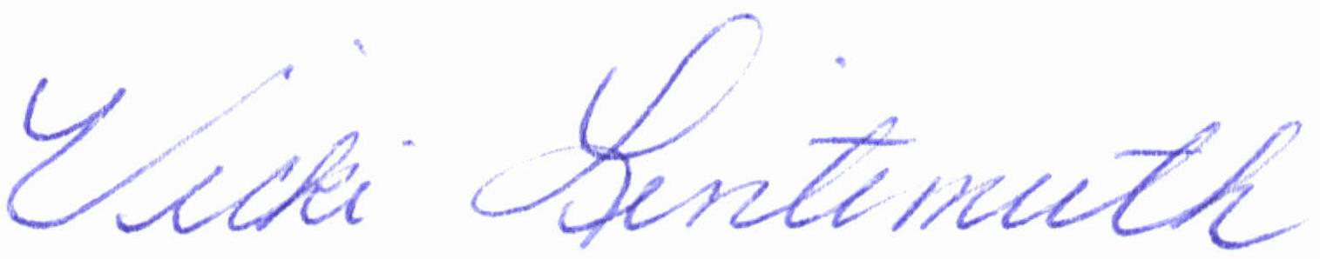
Vicki Lintemuth
MHM/vll
Enclosures
Cc: Paul J.Driscoll
Order No.: 01-17992-005

